Essex Boys and Girls Clubs
Residential Breaks Booking Form
The Jack Petchey Foundation have partnered with Essex Boys and Girls Clubs to offer young people an amazing opportunity to attend a 5-day adventure at our residential centre, Maes Y Lade, in the beautiful Brecon Beacons
for just £10 a person!
If your club members or young person is interested in attending, please complete the below booking form.
Name of person completing the form:
Contact Number: |  | Email Address:
Date form is completed
Below are the dates that are available please tick the box you would like to attend (You can also put a second option in if you would like in case your first choice is full – please make it clear which is your first choice).
Dates available | Tick date | Dates available | Tick Date
Friday 11th February - Tuesday 15th February |  | Friday 22nd July – Tuesday 26th July
Tuesday 15th – Saturday 19th February |  | Tuesday 26th July – Saturday 30th July
Friday 8th April – Monday 11th April |  | Saturday 30th July – Wednesday 3rd August
Friday 28th May – Tuesday 31st May |  | Wednesday 3rd August – Sunday 7th August
Tuesday 31st May – Saturday 4th June |  | Sunday 7th August – Thursday 11th August

Please list the names and ages of the young people that would like to attend:
Please note a consent form will need to be completed and returned for each young person along with payment to secure their place.
Names Of Young People Attending | Age | Name of young people Attending | Age

EBGC Affiliated Club
School
Other
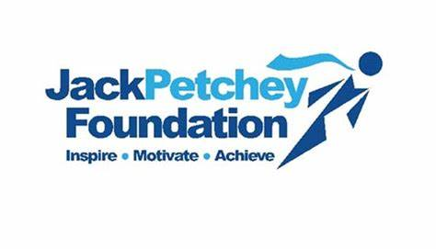
Connection to Essex Boys And Girls Clubs – Please state below your connection to us.
If you are from an affiliated club, or school please state which one.
If you select other (scout group, cadet unit etc…), please say where you found out about the trip.
If you have any questions, please contact the office on 01245 264783

